R Markdown Demo

Lim Zheng Yu

2022-05-26

# My first knitr document

## Introduction

**Markdown** is a very basic and easy-to-use syntax for styling written documents. It’s very easy to make some words **bold** and other words *italic* with Markdown. You can even [link to FCSIT](http://www.fsktm.um.edu.my)!

**Here is a code chunk and it prints the code and result.**

set.seed(1)  
x <- rnorm(100)  
mean(x)

## [1] 0.1088874

*Here is a code chunk but it only print the result.*

## [1] -0.1365489

Here is a code chunk but it doesn’t print anything!!!

Inline text computation

### The current time is Thu May 26 4:51:53 PM 2022.

summary(cars)

## speed dist   
## Min. : 4.0 Min. : 2.00   
## 1st Qu.:12.0 1st Qu.: 26.00   
## Median :15.0 Median : 36.00   
## Mean :15.4 Mean : 42.98   
## 3rd Qu.:19.0 3rd Qu.: 56.00   
## Max. :25.0 Max. :120.00

You can also embed plots, for example:

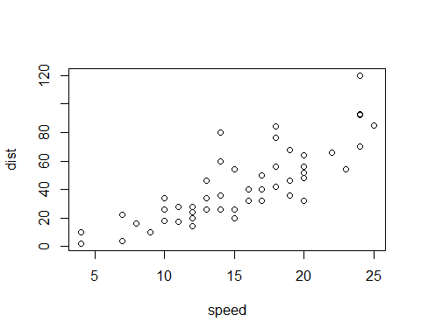

This is the violin plot for the dataset:

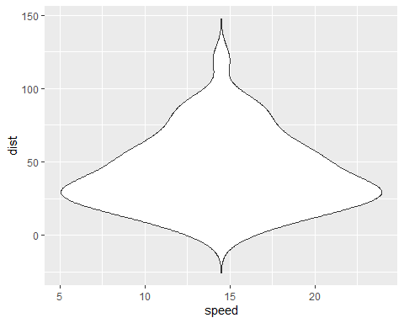

Another feature of R Markdown is the table:

| Day | Date |
| --- | --- |
| Monday | 23/5/2022 |
| Tuesday | 24/5/2022 |
| Wednesday | 25/5/2022 |
| Thursday | 26/5/2022 |
| Friday | 27/5/2022 |
| Saturday | 28/5/2022 |
| Sunday | 29/5/2022 |

Finally this is an image from the [Keukenhof](https://keukenhof.nl/en/) website: 